Identifying Factors Associated with Residence in Subsectors of a Rochester Neighborhood
Joseph Blubaugh, Anne Geraci, Rachael Glazner, Shannon Nitroy.
Class: STAT653 First Project Report
Date: 20 Feb 2017 (SP17 semester)

Background
Figure 1. Location of The Triangle in Rochester, New York | 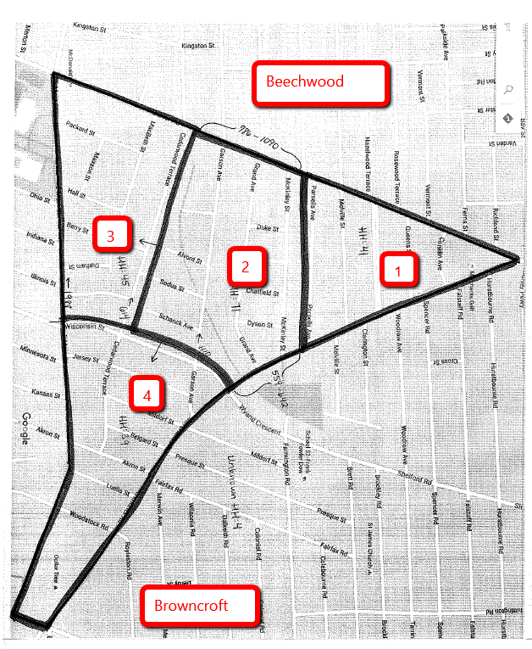  Figure 2. Sub-sectors of The Triangle
NeighborWorks® Rochester (New York) seeks to stabilize city neighborhoods through home ownership education, community-focused home improvement lending, and energy conservation services to families and individuals. We are working with community survey data collected by the NeighborWorks’ Healthy Blocks initiative. HealthyBlocks focuses on improving the physical conditions of homes, resident engagement and leadership, and neighborhood image and identity.
The current focus is a neighborhood in Rochester called the “Triangle of North Winton Village” (“The Triangle”), located between Culver Rd., Merchants Rd, and East Main St. in the Northeast quadrant of the city. The agency is particularly interested in detecting and quantifying differences between the four sub-sectors of the neighborhood, as pictured below.
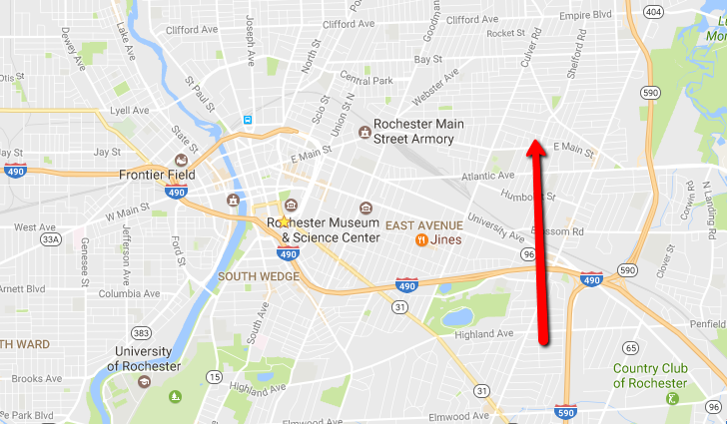

Project Objectives:
The primary objective for this project is to help the agency understand any statistically significant differences between the four geographical sectors, labeled 1 through 4, within the neighborhood, in an attempt to understand the different dynamics to better target outreach efforts. The agency hypothesizes that sector 4 will be different in nature from the other three sectors, due to its proximity to the relatively affluent Browncroft area. The main variables of interest to the community group are whether the subject would recommend the neighborhood to a friend and how the subject thinks the community will change in the next three years.
Part I of this project models the relationship between the response variable, Years of residence of the head of household, and various other factors, including home ownership and police and trash ratings, in order to gain insight into which factors influence length of time spent in the area.
Data – Source and Variables
The results of a mid-term survey (Year 3 of 5, calendar year 2016) are provided in the form of a spreadsheet. File includes 200 responses from a door-to-door survey of 450 households selected randomly from the 1200 households in the neighborhood. This response rate is very good for this type of survey, so the data may provide a fairly representative sample of the population.
Variable Name | Data Type: | Description of Variable
Neighborhood | Categorical | 1,2,3,4 represents neighborhood sub-section
Years | Continuous | Number of years you’ve lived here
OwnRent | Categorical, Fixed | Do you own, rent, live with family and friends, or other? (4 levels)
Age | Continuous | Age of person completing Survey. * We will assume this is the head of household
Gender | Categorical, Fixed | What is your gender? (Male, Female)
Race | Categorical, Fixed | To which race do you identify?
SatLevel | Categorical, Likert-4 | How Satisfied are you with the neighborhood?
Recommend | Categorical, Likert-4 | How likely are you to recommend living in this neighborhood?
Participation Score | Categorical, Fixed | Participation Score measures how active respondent is in community participation – resident association, volunteer, community improvement, supporting local businesses, social events, supporting local politics, and reporting incidents to authorities. LOW (up to 2), MED (3,4, or 5) or HIGH (6 and up)
PoliceRating | Categorical, Likert-5 | How would you rate police response?
FireRating | Categorical, Likert-5 | How would you rate fire department response?
EMSRating | Categorical, Likert-5 | How would you rate ambulance response?
TrashRating | Categorical, Likert-5 | How would you rate trash collection?
SnowRemoval Rating | Categorical, Likert-5 | How would you rate snow removal/street cleaning?
FeelSafeDay | Categorical, Likert-4 | How safe do you feel walking during the day?
FeelSafeNight | Categorical, Likert-4 | How safe do you feel walking at night?
FeelSafeChildren | Categorical, Likert-4 | How safe are children going to and from school?
FeelSafeElderly | Categorical, Likert-4 | How safe are senior citizens?
ChangePast3Y | Categorical, Likert-5 | How has the community changed vs. three years ago?
ChangeNext3Y | Categorical, Likert-5 | How will the community change in the next three years?

Methods
Because our data come from a survey rather than a designed experiment, we use our initial analysis to construct an ANCOVA regression on the log number of years the participant has resided in the area. The response is logged due to the skew in the distribution of years. It is an ANCOVA specification because our response variable is continuous and our explanatory variables are either discrete or continuous. We want to determine if the intercepts of our linear model differ for each subsector, so we will examine the coefficient of NeighborhoodID in particular. This is one dimension into determining overall differences in the four subsectors, but is also interesting because a naïve assumption may be that people who are happy with their location tend to stay there longer. If we can identify factors that lead to people staying in an area longer, we gain some information about how to make improvements, another goal of the NeighborWorks program. Our initial model, including all variables we believe may contribute to years of residence, is as follows:
log(Years) = NeighborhoodID + Age + RecommendCat + Gender + FeelSafeNightCat + SatLevelCat + Race + SnowRemovalCat + ParticipationScoreCat + OwnRent + PoliceRating + FeelSafeDayCat + TrashRatingCat
After removing insignificant covariates, but keeping NeighborhoodID because it is of interest, we are left with the following specification:
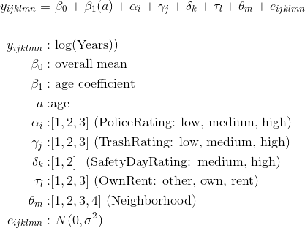
We used the software JMP to statistically analyze our data.
Results
Figure 3. Actual vs predicted values for model including neighborhood ID
Table 1. Model Output
First, we discuss the covariates left in the model and the implications of their significance. As shown in figure 3, Age has a positive coefficient as expected, as does the “own” category of OwnRent. The “rent” category has a negative coefficient, also as expected, since renters are less likely to stay put than homeowners. FeelSafeDayCat has a positive coefficient, which is also in line with expectations. The coefficients for PoliceRatingCat-high, and both levels of TrashRatingCat are negative, which is surprising, given that we would expect better police and trash services ratings to contribute to more years in the area. Neighborhood ID is not significant, but the years of residence is lower for sector 1 relative to sector 4, but higher for sectors 2 and 3 relative to sector 4 (Table 1). Figure 3 shows our R-squared value is 0.44, and the model tends to under predict the number of years in the area.
Table 2 shows the same table and graph with Neighborhood Id removed from the model. We see that the coefficient p-values change slightly, but the significance, signs, and R-squared remain the same. Therefore, we will keep the variable in our model.

Figure 4. Actual vs predicted values for model excluding neighborhood ID

Table 2. Output after removing Neighborhood ID

Next, we look further into differences between the four subsectors. Even though the coefficients were not significant, indicating that years of residence is not a statistically significant component of the differences in neighborhoods, we can still examine whether there were significant differences between the pairs of subsectors. We can see this is not the case, based on the Tukey HSD in table 3. No pairs of subsectors have significantly different years of residence, and the least squares means for each subsector are very close in value. Finally, in figure 4, we contrast each neighborhood against the other three combined and find no significant differences there as well.
Table 3. Estimates comparing subsectors
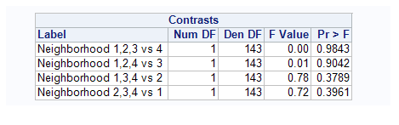
Table 4. Contrasts

Discussion
This simple ANCOVA model provides insight into one of the many facets of this dataset. We find that people tend, on average, to live in each of the four subsectors for the same amount of time. We also find that age, home ownership, and a high rating of feeling safe during the daytime are positively related to years of residence, while renting a home, high police force and trash removal ratings are negatively related to years of residence. The coefficient on renting makes sense, renting and moving sooner are related, with causality going in both directions. The coefficients for police and trash have unexpected signs, however, because we expect better community services to motivate people to stay longer. This surprise in signs may indicate we have omitted variable bias. Finally, we find little to no evidence that the years of residence differs between any two of the four subsectors of this area, or any one subsector compared to the other three.

